**Project Design Phase-II**

**Data Flow Diagram & User Stories**

|  |  |
| --- | --- |
| Date | 4 November 2022 |
| Team ID | PNT2022TMID10453 |
| Project Name | Project – Smart Lender-Applicant Credibility Prediction for Loan Approval. |
| Maximum Marks | 4 Marks |

**Data Flow Diagrams:**

A Data Flow Diagram (DFD) is a traditional visual representation of the information flows within a system. A neat and clear DFD can depict the right amount of the system requirement graphically. It shows how data enters and leaves the system, what changes the information, and where data is

stored.

**Flow:** [**(Simplified)**](https://developer.ibm.com/patterns/visualize-unstructured-text/)

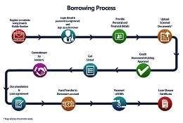

•••••• **The user can register in website by using Email and Mobile number. The user can Login by using Email and password as Registered in the respective website. The user will provide peUser should upload the scanned documents. Then it will goes to approval process. Finally they will get loan closure certificate. rsonal and financial details.**

**User Stories**

Use the below template to list all the user stories for the product.

|  |  |  |  |  |  |  |
| --- | --- | --- | --- | --- | --- | --- |
| **User Type** | **Functional**  **Requirement**  **(Epic)** | **User Story**  **Number** | **User Story / Task** | **Acceptance criteria** | **Priority** | **Release** |
| Customer  (Mobile user) | Registration | USN-1 | As a user, I can register for the loan application by entering my email/user number, password, and confirming my password. | I can access my account / dashboard | High | Sprint-1 |
|  |  | USN-2 | As a user, I will receive confirmation email once I have registered for the loan application | I can receive confirmation email & click confirm | High | Sprint-1 |
|  |  | USN-3 | As a user, I can register for the loan application through Facebook | I can register & access the dashboard with Facebook Login | Low | Sprint-2 |
|  |  | USN-4 | As a user, I can register for the application through Gmail | I can receive the mail that you are registered in loan application. | Medium | Sprint-1 |

**DFD Level 0 (Industry Standard)**

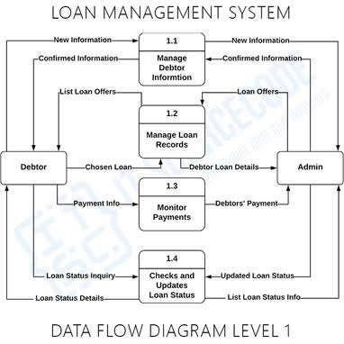

|  |  |  |  |  |  |  |
| --- | --- | --- | --- | --- | --- | --- |
|  | Login | USN-5 | As a user, I can log into the application by entering email & password | I can receive the message that your ID is get loin. | High | Sprint-1 |
|  | Dashboard | USN-6 | As a user, I can use the dashboard it will  Display the summary of the total loan process. | I can access my dashboard to view entire summary of the loan application. | medium | Sprint-1 |
| Customer (Web  user) | Registration | USN-7 | As a User, I can register for loan website by entering my email, password, and confirming my password. | I can receive my acceptance mail | high | Sprint-1 |
| Customer Care Executive | Doubts | USN-8 | As a new user how can I create my account. As a old user how can I resolve the issues. | Clarification doubts through phone call or by Gmail. | Medium | Sprint-1 |
| Administrator | Holding all Details | USN-9 | Giving approval to the particular user ID. | Approval. | High | Sprint-1 |
|  |  |  |  |  |  |  |
|  |  |  |  |  |  |  |
|  |  |  |  |  |  |  |